**Impact of diet quality on personality and behavioural syndromes of the delicate skink**

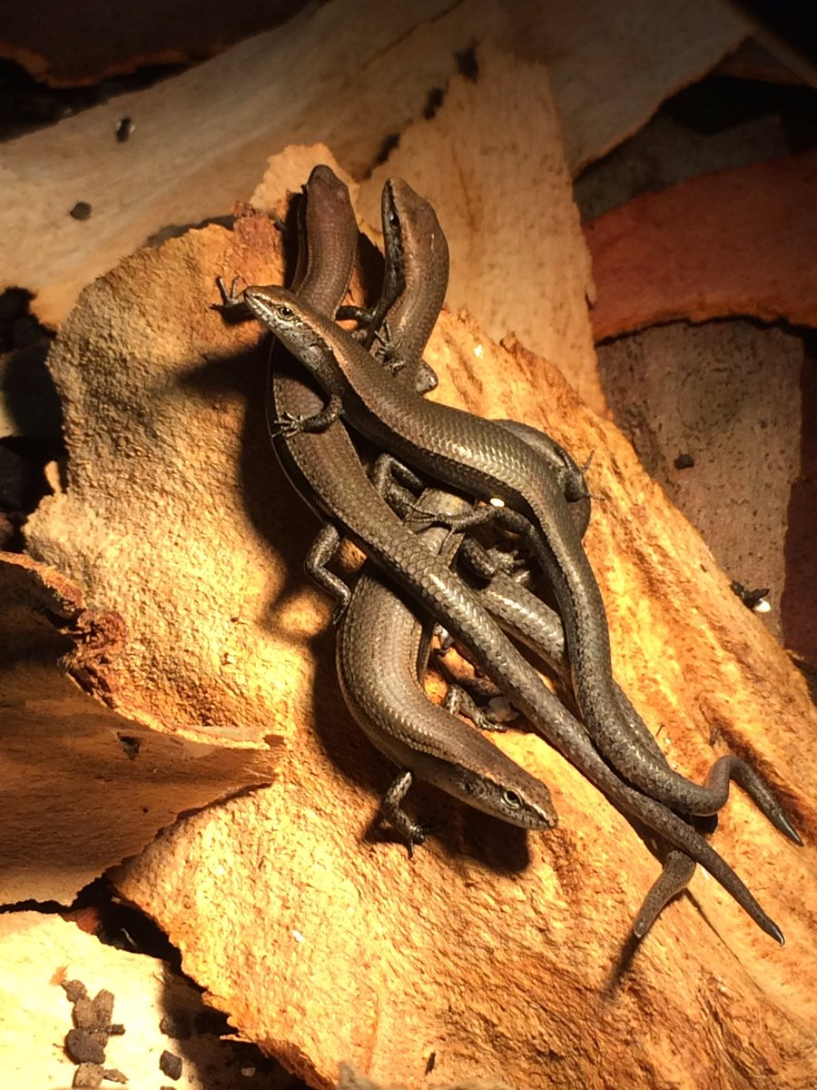

**Kyleen A. Lopez**

Supervisor: Dr Daniel Noble

Submitted in partial fulfilment of the requirements for the degree of Bachelor of Environmental Science,

School of Biological, Earth and Environmental Sciences,

Faculty of Science,

The University of New South Wales

October 2017



**The University of New South Wales**

**Faculty of Science**

**School of Biological, Earth and Environmental Sciences**

***Honours thesis project declaration page***

I hereby declare that this submission is my own work and to the best of my knowledge it contains no materials previously published or written by another person, nor material which to a substantial extent has been accepted for the award of any other degree or diploma at UNSW or any other educational institution, except where the acknowledgement is made in the thesis. Any contribution made to the research by others, with whom I have worked at UNSW or elsewhere, is explicitly acknowledged in the thesis.

I also declare that the intellectual content of this thesis is the product of my own work, except to the extent that assistance from others in the project's design and conceptions or in style, presentation and linguistic expression is acknowledged. I have also submitted a digital copy of this thesis

Word count excluding references, tables and captions: ………………………….



(Signed) Date: 26/10/2017

Thesis committee:

Supervisor: Daniel Noble

Examiners: Michael Kasumovic

Terry Ord

I am fully aware that the School retains a copy of the thesis and is free to allow them to be consulted or borrowed. The thesis may be restricted for up to 2 years or longer by a written request to the Head of School.

Acknowledgements

I would like to thank my supervisor, Daniel Noble, for his continued guidance and feedback during the year. To Fonti Kar who has helped me in every stage of the process, keeping me calm and accountable when meeting deadlines. I would also like to thank the Lizard Lab at Macquarie University for their assistance during the experimental phase of this project. Finally, huge thanks go to my friends and family for their unwavering support and encouragement. In particular, Fiona Robinson who taught me the basics of R and Joel, John and Krissy for carrying me through the year and confiscating my distractions as I wrote my thesis. I wouldn’t have finished this without them.

CONTENTS

Introduction……………………………….……………………………….5

Methods……………………………….…………………………………...9

Capture and Husbandry……………………………………………9

Diet Manipulation………………………………………………….9

Behavioural Assays………………………………………………..10

Behavioural Scoring……………………………………………….12

Statistical Analysis……………………………….………………..13

Results……………………………….……………………………………..15

Personality and behavioural syndromes in *L. delicata*.……………15

Does diet impact personality and behavioural syndromes?.……….19

Discussion…………………………….……………………………………23

Personality and behavioural syndromes in *L. delicata*.……………23

Dietary impacts on personality and behavioural syndromes………19

Conclusion…………………………….……………………………………26

References

ABSTRACT

Macronutrient composition and diet quality have been shown to affect behavioural traits in a range of species, mostly in invertebrates and birds. Few studies, however, have focused on reptiles, much less in the delicate skink (*Lampropholis delicate*) despite evidence for behavioural syndromes in this species. In this study, I altered the overall diet quality of adult female *L. delicata* and quantified personality and behavioural syndromes of each diet treatment to understand the impact diet may have on changes in behaviour of the delicate skink. While I found strong evidence for the existence for personality and behavioural syndromes in *L. delicata*, the behavioural traits themselves, and the correlation between them (behavioural syndromes), were unaffected by diet quality. It is possible that I did not detect major changes in behavioural syndromes and personality because dietary insults orchestrate changes only during critical developmental periods and personality traits are generally established during early developmental periods. Juveniles therefore, maybe more susceptible to environmentally induced behavioural changes (Lindstorm 1999, Radmilovich et al. 2003), compared to adults which remained resistant to shifts in diet quality.

INTRODUCTION

The significance of animal personality has been overlooked by many ecologists and evolutionary biologists, despite its ecological implications (Dingemanse and Reale 2005). Only traits that have direct impacts on fitness have been thoroughly explored by scientists, including aggression and anti-predator behaviour (Ellis et al. 2006). Some traits show consistent between-individual variation across environmental conditions (i.e., personality), such as boldness in periods of high predation (Reale and Feste-Bianchet 2003). Functionally different behaviours can also be linked, resulting in behavioural correlations (Van Oers et al. 2005). These correlations can appear in the same individual over time (within-individual) as well as across the population (between-individual) (Han and Dingemanse 2015). Variation between individuals where each individual behaves consistently in different contexts is known as repeatability and demonstrates personality (Bell et al. 2009; Wolf and Weissing 2012). Consistent between individual covariance between personality traits are defined as behavioural syndromes (Sih et al 2004, Sih et al. 2012a).

Diet quality refers to the caloric value and nutritional composition of food and impacts behaviour in many species (Ishizaki et al. 2001). For example, dietary acids impact the schooling behaviours of larval yellowtail (Ishizaki et al. 2001) and guppy populations become more social in nutrient-limited environments (Trompf and Brown 2014). In habitats with low quality food resources, animals can modify foraging behaviour to selectively consume food and meet nutritional and energetic needs (Behmer et al. 2003). In situations where nutritionally limited diets are inescapable, animals will prioritise consumption of the most important nutrients, usually at the cost of others (Han and Dingemanse 2015). The resulting nutritional imbalance influences physiology, growth, survival and behaviour (Han and Dingemanse 2017).

Diet quality impacts behaviour through the influence of macronutrient composition on early life stage, neural development and gut microbiota (Han and Dingemanse 2015, Castillo et al. 2007). Macronutrient composition in an individual’s diet can trigger differential gene expression that can subsequently affect behaviour (Mason et al 2016, Rocha et al 2016). Carbohydrates are the main source of energy that increases metabolic rate, which is predicted to lead to higher levels of exploration (Maklakov et al. 2008, Mathot and Dingemanse 2015). Protein deficient invertebrates become bolder since there is a greater cost for individuals with sufficient protein levels to be bold (Dingemanse and Wolfe 2010).

Diet also influences gut microbial communities which can affect general activity patterns and anxiety (Castillo et al. 2007, Heijtz et al. 2011). More specifically, the fibre content of a diet seems to be particularly important in changing the gut microbiome (Bach Knudsen and Jensen, 1991). Since stress, anxiety and social behaviours are influenced by the gut microbiota composition in humans (Parashar and Udayabunu 2016), this change may also impact animal behaviour. Mice, for example, exhibit higher motor activity levels and lower anxiety behaviours when they lacking normal gut microbial communities (Heijtz et al. 2011). This is because microbiome colonization may trigger neural signaling mechanisms involved in motor activity and anxiety (Heijtz et al.) Diet quality also regulates neuroendocrine mechanisms which influence sociability (Soares et al 2010). Since poor nutrition has negative effects on neuromuscular development, it is expected that social behaviours will suffer as a result of low quality diets (Akman et al. 2012).

Nutritional composition in the early stages of an animal’s life can affect behaviours expressed at maturity (Han and Dingemanse 2015). However, few observations have been made regarding the short-term impacts of diet quality on adults. Short-term effects have predominately been observed in grazing behaviours of agriculturally significant mammals where cattle and sheep have been shown to graze more efficiently after fasting (Greenwood and Demment 1988, Newman et al. 1994). Differences in phosphorus availability and protein:carbohydrate ratios cause changes in courtship behaviours of crickets (Maklakov 2008, Bertram et al. 2009). These short-term impacts may have huge implications for subsequent fitness and should therefore be explored across all species, rather than a selected few.

Genetic variation is closely linked to the presence of behavioural syndromes and can be affected by diet (Sih et al. 2004, Han and Dingemanse 2015). Nutritionally balanced diets can release cryptic genetic variation in behavioural expression (Charmantier and Garant 2005). However, if nutritional imbalances increase the expression of a trait (for example, foraging), genetic variation will also increase (Han and Dingemanse 2015). Behavioural syndromes are a combination of between-individual variation and personality (Sih et al. 2004). Since genetic variation across the population has subsequent impacts on the differences in behaviours expressed between-individuals (Dochtermann and DIngemanse 2013), behavioural syndromes will be impacted. Thus, the impact of diet on genetic variation will also ultimately impact behavioural syndromes.

Behavioural syndromes may be adaptive or non-adaptive depending on the environmental context. For example, behavioural syndromes can be an evolutionary constraint when the underlying genetic correlations restricts the adaptability of a population to selection pressures moving in the opposite direction of the syndrome (Dochtermann and Dingemanse 2013). In contrast, correlations can be adaptive if favored by correlational selection. For example, positive correlations between boldness and aggression in sticklebacks have presented themselves when there is high predator density and weakened or disappeared entirely in populations under less predatory pressure (Bell and Sih 2007). Whether such shifts in behavioural syndrome exist when diet quality is altered is yet to be completely understood.

Meta-analyses suggest that ectotherm personality may be strongly dependent on external factors (Bell et al. 2009). Low quality diets in some spider species reduce repeatability of boldness and aggressiveness (Lichtenstein et al. 2016). Testosterone is associated with persistence of responses to multiple stimuli (Andrew 1972) and repeatable aggression in changing environments (Wingfield 1994), suggesting personality may be more prevalent in males. However, *L. delicata* specifically, have shown little evidence that there are sexual differences in behavioural traits and correlations (Michalengeli et al. 2016). While the behaviours remain similar between males and females, the subsequent impacts of diet quality could be differenct as males and females have different nutritional demands (Reddiex et al. 2013).

The traits used in this study are derived from three of the five behavioural types proposed by Reale et al. (2007) that make up personality including neophobia, exploration and sociability. Neophobia refers to an individual’s hesitation to interact with an unfamiliar item (Beissinger et al. 1994) and is only relevant when studying individual variation (Greenberg and Mettke-Hoffman, 2001), as in this project. Exploration is the general activity of an individual in a neutral environment and should be tested in a non-threatening and familiar environment so as not to confound results with neophobia (Barnett and Cowan 1976, Renner 1990). Sociability is an animal’s willingness to interact with a conspecific in a non-aggressive manner (Reale et al. 2007).

This study used female delicate skinks (*Lampropholis delicata*) to compare the effects of a high- and a low-quality diet on personality and behavioural syndromes. Delicate skinks are an invasive species that are now abundant in Eastern Australia, New Zealand, Hawaii and Lord Howe Island (Peace 2004). *L. delicata* are also generally highly social and exploratory and less neophobic (Chapple 2003, Duffield and Bull 2001, Michelangeli 2016) and have exploited novel environments to become successful colonizers (Chapple 2011). Behavioural syndromes can change in novel environments, allowing the population to adequately respond to environmental changes (Bell and Sih 2007). Therefore, I expect to observe behavioural changes in response to diet quality in *L.delicata* (Lee 2002).

Specifically, I hypothesise that the potential for shared foraging information (Trompf and Brown 2014) will increase sociability levels in the low-quality group. Since the low-quality group may lack the required carbohydrates necessary for high levels of exploration, I predict that they will also be less exploratory (Mathot and Dingemanse 2015). Also, lower protein levels are associated with increased boldness (Dingemanse and Wolf 2010) and may therefore show that the low-quality group will be less neophobic than the high-quality group.

METHODS

**CAPTURE AND HUSBANDRY**

Sixty-four female *L. delicata* were collected in the Sydney region in September 2015 by mealworming. For the duration of the experimental period, each female was placed in separate enclosures measuring 35.5 x 27.5 x 15cm with paper substrate, a home hide box and water bowl. Incandescent 100-W bulbs provided a heat to allow thermoregulatory opportunities and the average room temperature was kept at 24ºC. Lizards were fed crickets three times weekly and had access to water *ad libitum*.

**DIET MANIPULATION**

Diet manipulation was carried out in accordance with previous work in lizards (Warner et al. 2007). To establish diet treatments, crickets were divided into two groups. One group was fed a combination of cat food and an assortment of vegetables (i.e. ‘high quality’ diet; n = 32) while the other was given only corn (i.e. ‘poor quality’ diet; n = 32). Crickets were maintained on these diets for two weeks to ensure the crickets in the two treatments were more likely to be of different diet quality. Although specific aspects of diet modified were unknown (e.g. protein-carbohydrate ratio), previous studies have used a similar method to generate distinct treatments (Warner et al. 2007). Crickets were then fed to random female subjects for 3.5 months, forming two treatment groups. The lizards were kept on the same diet for the duration of the experiment.

**BEHAVIOURAL ASSAYS**

After the 3.5 months of diet manipulation, behaviour was assayed daily for 14 days on all 64 female lizards. I assayed activity, neophobia and sociability. All assays were run consecutively on the same day (separated by ~ 10 minute intervals) in a temperature-controlled room set at 28ºC for the duration of the experiment. Each assay was recorded for 20 minutes between 0800-1100hr, and behaviours were recorded using CCTV cameras (model H.264, CCTV security systems, Melbourne, VIC). We used blinds (i.e. black sheets) to prevent lizards from being disturbed by observers during trials. Room temperature was also recorded to account for any day to day temperature fluctuations, but generally the room temperatures were fairly consistent across days. To reduce order effects, we randomised neophobia and sociability assays after an initial exploration assay. Below I discuss each of the assays in more detail.

***Exploration***

Exploration assays involved quantifying daily activity patterns for each lizard. I first added a second, experimental hide, to each individual’s enclosure and removed all water dishes. The home hide was removed during the trials so the individuals were prompted to explore their enclosure and ensure that the tracking software could establish their initial location. Assays began as soon as the home hide was removed, exposing the lizard. For each lizard, we quantified the total distance moved (cm) in 20 minutes as a measure of general activity / exploration patterns.

***Neophobia***

Neophobia assays involved quantifying the response of each lizard to a novel food or object in their home environment. I first fixed a novel item to a transparent circular cutout and placed this in the enclosure approximately 10 cm from the experimental hide (Figure 1). All discs were tacked down using BlueTaq to prevent it from being dislodged from its location during the trial. I used a number of food or objects, and rotated between a novel food and object every other day. I ensured that new items were presented every day to maintain novelty of items over the duration of the experiment. To quantify neophobia, I recorded the amount of time the lizard spent in the novel zone, which was defined as the total time (seconds) the lizard spent within an approximately 4cm radius of the novel item. I also quantified the latency to interact (i.e. place its head and forearms on the disc) with the novel item (seconds) (also known as Novel Latency).

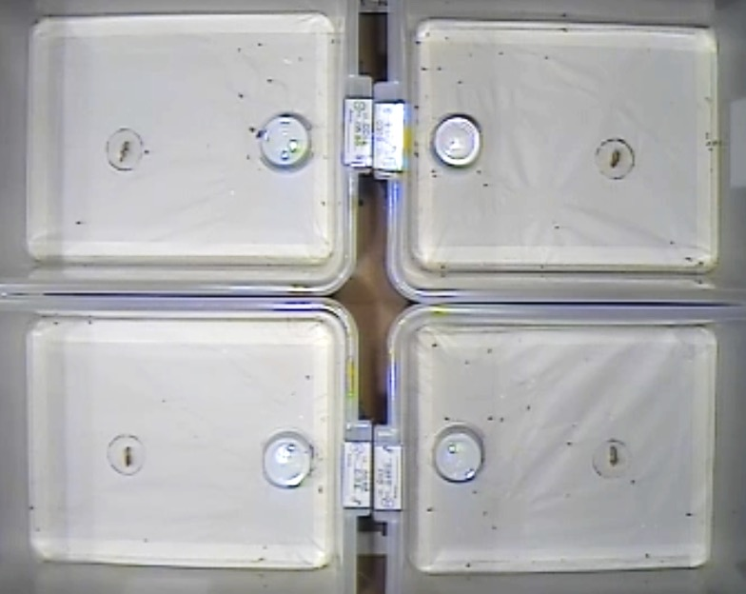

**Figure 1 –** Example of layout showing the relative location of the novel item to the home hide for neophobia assay.

***Sociability***

*Lampropholis delicata* naturally occurs at very high densities and is quite social (Chapple 2003). I therefore quantified the response of each lizard to a conspecific male lizard to understand differences in sociability between lizards and whether this could be impacted by diet. Male lizards independent of the experiment were placed into transparent containers and introduced into each lizard’s enclosure on the opposite side of the enclosure from the experimental hide (Figure 2). The experimental lizard only had visual cues from the conspecific male during the assay. During the 20-minute assay, I quantified the total amount of time (seconds) each lizard spent in the ‘social zone’, defined as the area of the enclosure within ~ 3 cm perimeter around the front of the container with the conspecific male.

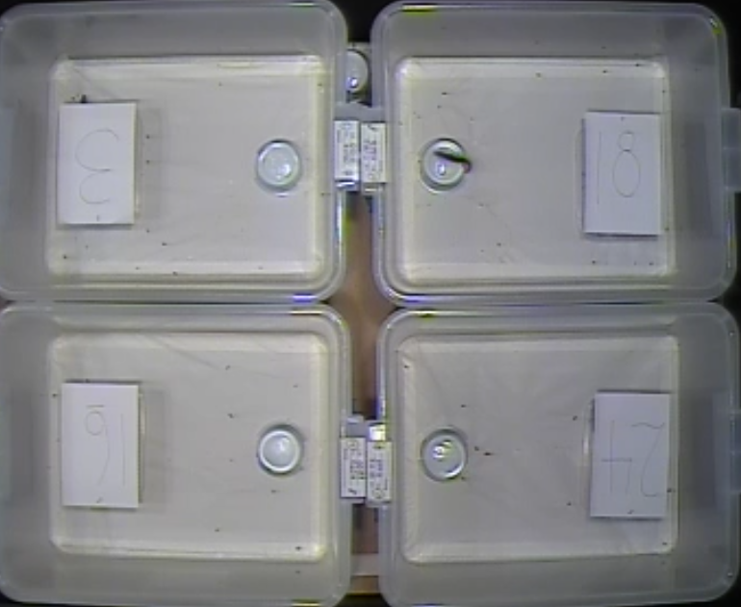

**Figure 2 –** Excerpt from social assay video showing the relative location of the social lizard to the home hide.

**BEHAVIOURAL SCORING**

All behavioural assays were scored blind to the treatment group of the experimental lizard using the automated tracking software Ethovision XT 11.5. Automated tracking significantly reduces collection time, nullifies inter-observer effects and allows for more precise behavioural measures.

Arenas (i.e. a single enclosure within a video) were defined in the program for each assay to measure a number of variables in each zone (Figure 3). Figure 4 is an example from the neophobia assay, showing the movement of the individuals during the assay that were recorded. Data from 20 minutes of each video was acquired. In some cases, individuals were not immediately detected during tracking but a full 20 minutes was still acquired, albeit a later segment.

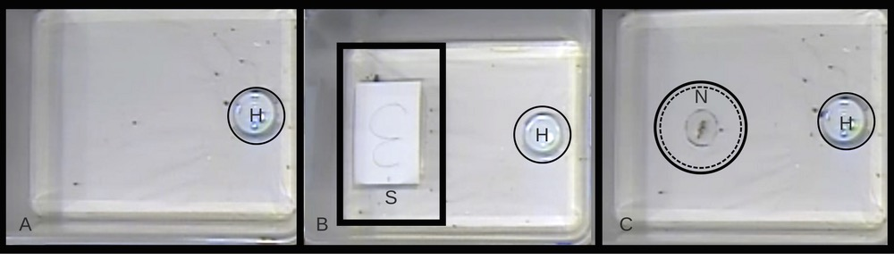

**Figure 3 –** Zones defined in A. Exploration assay, B. Social Assay and C. Neophobia Assay. H = home hide; S = Social Zone; N = Novel Zone

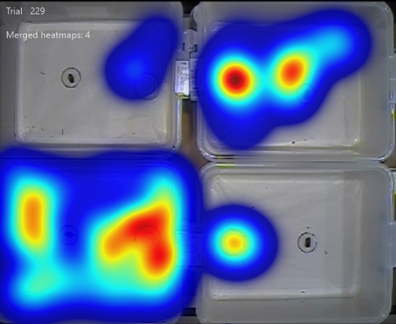

**Figure 4 –** Heatmap from a neophobia assay displaying the movement of each individual over the 20-minute recording. Bottom left individual was on a low-quality diet and all others were on a high-quality diet.

**STATISTICAL ANALYSIS**

Lizard activity patterns were highly variable, with lizards on a given assay not always emerging from hides. This led to variables being censored (i.e. activity was probably low on a given assay, but not completely absent) as behaviours were not picked up in the 20-minute assay. Censored distributions in a multi-variate framework are difficult to model, and as such, I only used data for assays where lizards were active. In other words, where lizards were detected for at least 30 seconds. While this led to a drop in the total number of observations, the data set was still quite large overall and any decrease in sample size is likely to lead to conservative model estimates (increasing Type II errors). To meet assumptions of normality, the total distance moved, time spent in the novel zone and time spent in social zone were log transformed. I modelled all variables together in a multi-response model using the *MCMCglmm* package (Hadfield, 2010) in R (R Core Team 2014). *MCMCglmm* uses a Bayesian framework to estimate covariance matrices between behavioural traits at different hierarchical levels of the data. It uses a Markov Chain Monte Carlo (MCMC) sampling approach to fit models and partitions covariance matrices into between- and within-individual levels, which I could estimate given the substantial repeated measurements on the same lizard. The between-individual matrices showed covariation across the population while the within-individual matrices revealed the covariation between assays occurring in each individual.

I first ran intercept only models to partition out the covariance matrix at the between and within-individual levels not conditioning these estimates on any fixed effects. I modelled lizards in each diet treatment separately for these analyses. From these models, I estimated the repeatability of traits by estimating the intra-class correlation coefficient (ICC) as the proportion of variance at the between individual-level divided by the total variance for a given trait (Nakagawa and Shieldheith, 2010). In the second set of models, I included the final mass of each individual as a fixed effect to account for the impact of body size may have on behaviour, and as such, covariance matrices were conditioned on mass as a sensitivity analysis. To estimate behavioural syndromes (i.e. correlations between traits at the between-individual level), correlation matrices were estimated using the between-individual covariance matrices estimated from the above models. Covariance matrices were converted to correlation matrices using the *cov2cor* function on the posterior modes of each model.

To test whether diet impacted personality or behavioural syndrome structure, I compared the between individual level covariance matrices generated for the low-diet treatment to the same matrices generated from the high-diet treatment using a Mantel test. I also tested whether the diet treatments differed by modelling the combined diet treatment data using a multi-response model and including ‘diet–treatment’ as a categorical input variable to test whether it impact the covariance matrices in the model significantly. I also used t-tests to compare the average behaviours in the two treatments. I used the 95% credible intervals generated for repeatability estimates to compare whether repeatability differed between the low and high-quality treatment groups. Credible intervals that did not overlap each other were considered significant.

In all cases models were run for 70 000 iterations with a burn-in period of 10 000 iterations, and a thinning rate of 100, ensuring that I had 600 samples from the posterior distribution. For the between and within-individual covariance matrices I used an inverse-Wishart priors (V= $\left[\begin{matrix}1 & 0 \\ 0 & 1\end{matrix}\right]$, nu = 0.01), where V is a covariance matrix where the covariance between traits was set as zero and their variance was assumed to be one. The definition of *nu*, is simply the degree of belief in how likely one thinks V is the true covariance matrix. Lower values imply that the V matrix is unlikely and results in an uninformative prior. In all models, I ensured that the MCMC chains were mixing well by examining the trace plots (plots of the parameters over successive MCMC samples). Credible intervals (similar to confidence intervals) are also presented in the tables and are considered significant when the interval does not include zero.

RESULTS

***Personality and behavioural syndromes in L. delicata***

All behavioural traits measured were significantly repeatable with confidence intervals not overlapping zero in all cases (Table 1). Exploration was consistently the most repeatable in both high (ICC = 0.386, CI = 0.221, 0.547)and low (ICC = 0.551, CI = 0.329, 0.693) diet treatments.

***Table 1*** *– Repeatability (intra-class correlation – ICC) behavioural trait for both high and low treatment groups along with confidence intervals presented in brackets. All repeatability estimates are significant.*

|  |  |  |  |  |
| --- | --- | --- | --- | --- |
|  | Exploration | Novel (Latency) | Novel Duration | Social |
| High | 0.386 (0.221, 0.547) | 0.288 (0.165, 0.485) | 0.246 (0.090, 0.386) | 0.349 (0.178, 0.524) |
| Low | 0.551 (0.329, 0.693) | 0.208 (0.096, 0.396) | 0.264 (0.128, 0.465) | 0.362 (0.183, 0.601) |

Between-individual correlation matrices provide strong evidence that behavioural traits formed a behavioural syndrome (Tables 2 & 3). Total distance moved (exploration) and the latency to approach a novel food item exhibited a significant negative correlation in both treatment groups (high = -0.992, CI = -0.991, -0.541; low = -0.948, CI = -0.998, -0.788). More active individuals were more likely to explore and interact with novel food items (Figure 5a). Sociality and novel latency also had strong negative correlations (high = -0.804, CI = -0.994, -0.563; low = -0.985, CI = -0.994, -0.575) implying that more social individuals were also more likely to quickly interact with the novel item (Figure 5b). Distance moved and time spent in novel zone were positively correlated (high = 0.303, CI = 0.152, 0.893; low = 0.697, CI = 0.314, .920) with more exploratory individuals also spending more time in the novel zone (Figure 5c). Novel duration also had a much stronger positive correlation with sociality (Figure 5d) in both treatment groups (high = 0.773, CI = 0.515, 0.992; low = 0.950, CI = 0.854, 0.997). More social individuals were also more likely to explore (Figure 5e) more with significant positive correlations existing between sociality and distance moved (high = 0.454, CI = 0.239, 0.822; low = 0.581, CI = 0.307, 0.896).

***Table 2*** *–* Correlations (bottom left shaded area), variance (diagonal) and covariance (non-shaded area above diagonal) at the between individual level between behaviours quantified on animals from the high-quality Diet treatment group with confidence intervals for each value presented in brackets. All values are significant.

|  |  |  |  |  |
| --- | --- | --- | --- | --- |
|  | Exploration | Novel Latency | Novel Duration | Social |
| Exploration | 0.279 (0.131, 0.559) | -71.693 (-137.282,  -24.375) | 0.088 (0.003, 0.366) | 0.181 (0.066, 0.467) |
| Novel Latency | -0.922 (-0.991, -0.541) | 21670.07165 (11245.29,51247.953) | - | -76.332 (-162.785,  -27.117) |
| Novel Duration | 0.303 (0.152, 0.893) | - | 0.268 (0.100, 0.499) | 0.269 (0.095, 0.503) |
| Social | 0.454 (0.239, 0.822) | -0.804 (-0.994, -0.563) | 0.773 (0.515, 0.992) | 0.416 (0.198, 0.830) |

***Table 3*** *–* Correlations (bottom left shaded area), variance (diagonal) and covariance (non-shaded area above diagonal) at the between individual level between behaviours quantified on animals from the low-quality diet treatment group with confidence intervals for each value presented in brackets. All values are significant.

|  |  |  |  |  |
| --- | --- | --- | --- | --- |
|  | Exploration | Novel Latency | Duration | Social |
| Exploration | 0.344 (0.194, 0.798) | -64.956 (-146.449, -25.492) | 0.226 (0.052, 0.525) | 0.301 (0.036, 0.532) |
| Novel Latency | -0.948 (-0.998,  -0.788) | 13663.244 (7000.125, 36543.067) | - | -65.371 (-138.861,  -21.407) |
| Novel Duration | 0.697 (0.314, 0.920) | - | 0.240 (0.096, 0.629) | 0.260 (0.113, 0.617) |
| Social | 0.581 (0.307, 0.896) | -0.985 (-0.994, -0.575) | 0.950 (0.854, 0.997) | 0.322 (0.114, 0.713) |

1. High = -0.922 Low = -0.948 b. High = -0.804 Low = -0.950

c. High = 0.303 Low = 0.697 d. High = 0.773 Low = 0.950

e. High = 0.454 Low = 0.851

***Figure 5*** *– Scatterplots representing the correlations between* ***a.*** *Exploration (Log Total Distance moved (cm)) and Novel Latency (Latency to first novel zone entrance (s));* ***b.*** *Novel Latency and Sociality (Log time spent in social zone (s));* ***c.*** *Exploration and Novel Duration (time spent in novel zone (s));* ***d.*** *Novel Duration and Sociality; and* ***e.*** *Exploration and Sociality. Each plot shows both high (pink) and low (blue) data. All correlations are significant yet there is no significant difference between treatment groups.*

At the within-individual level, individuals exhibited similar correlations between traits (Tables 4 & 5). Activity was negatively correlated with time to approach a novel food item (high = -0.193 CI = -0.265, -0.015; low = -0.243 CI = -0.357, -0.086) and also positively correlated with the time spent interacting with a conspecific (high = 0.129, CI = 0.024, 0.278; low = 0.403, CI = 0.257, 0.517). While there was within-individual variability, lizards that were more exploratory on a given day also interacted more quickly with novel objects and were more social. Sociality was weakly and positively correlated with time spent in novel zone (high = 0.113, CI = -0.047, 0.234; low = 0.133, CI = 0.038, 0.294) and had weak negative correlations with novel latency (high = -0.122, CI = -0.236, 0.051; low = -0.239, CI = -0.349, -0.092). More social individuals were also more exploratory on the same day and spent more time in the novel zone. Finally, total distance moved and novel duration also had a weak positive correlation (high = 0.171, CI = 0.046, 0.314; low = 0.131, CI = 0.032, 0.298), indicating that neophobic individuals tended to be less exploratory. The combination of significant repeatability values and within-individual correlations that persisted between-individuals provides strong evidence that personality and behavioural syndromes exist.

***Table 4****: Correlations (bottom left shaded area), variance (diagonal) and covariance (non-shaded area) within individuals for each assay High Diet treatment group with Confidence Intervals for each value presented in brackets. Insignificant values in bold.*

|  |  |  |  |  |
| --- | --- | --- | --- | --- |
|  | Exploration | Novel Latency | Novel Duration | Social |
| Exploration | 0.464 (0.409, 0.593) | -32.282 (-46.081,  -2.412) | 0.107 (0.014, 0.193) | 0.076 (0.013, 0.178) |
| Novel Latency | -0.193 (-0.265,  -0.015) | 56207.643 (47426.42,69409.688) | - | **-25.812 (-49.382, 10.927)** |
| Novel Duration | 0.171 (0.046, 0.314) | - | 0.822 (0.668, 0.999) | **0.087 (-0.036, 0.188)** |
| Social | 0.129 (0.024, 0.278) | -0.122 (-0.236, 0.051) | 0.113 (-0.047, 0.234) | 0.742 (0.614, 0.904) |

***Table 5:*** *Correlations (bottom left shaded area), variance (diagonal) and covariance (non-shaded area) within individuals for each assay Low Diet treatment group with Confidence Intervals for each value presented in brackets. All significant.*

|  |  |  |  |  |
| --- | --- | --- | --- | --- |
|  | Exploration | Novel Latency | Novel Duration | Social |
| Exploration | 0.387 (0.327, 0.491) | 35.768(-56.750, -11.855) | 0.071 (0.015, 0.184) | 0.184 (0.110, 0.269) |
| Novel Latency | -0.243 (-0.357, -0.086) | 56207.643 (46345.27, 67697.385) | - | -41.664 (-64.935, -15.380) |
| Novel Duration | 0.131 (0.032, 0.298) | - | 0.740 (0.649, 0.979) | 0.085 (0.020, 0.206) |
| Social | 0.403 (0.257, 0.517) | -0.239 (-0.349, -0.092) | 0.133 (0.038, 0.294) | 0.539 (0.440, 0.681) |

***Does diet impact personality and behavioural syndromes?***

There were no significant differences observed between the behaviours of the high and low group (Figure 6; Exploration p = 0.28, Sociality p = 0.10, Novel Latency p = 0.76, Novel Duration p = 0.51). The average distances travelled were particularly close between the high (r = 5.65) and low (r = 5.82, t = -2.76, df = 62) treatment groups. The same can be said for average time taken to interact with novel item (high = 760.23; low = 777.89, t = 0.67, df = 62) and time spent in the novel zone (high = 2.52; low = 2.31, t = 0.67, df = 62). While there was a trend for lizards on a high-quality diet to be more social compared to those on a low-quality diet, spending on average 0.68 (log transformed) seconds more time in the social zone, this difference was not significant (p = 0.10, t = 1.68, df = 62). These results indicate that individuals fed on a high-quality diet do not spend more or less time in the relevant zones than those fed low-quality diets.

Repeatability estimates of behaviours (i.e. personality) were also unaffected by diet treatment (Figure 7). The low diet group has a higher exploration repeatability (high r = 0.386, CI = 0.221, 0.547; low r = 0.551, CI = 0.329, 0.693) than the low treatment group but, again, this value is not significant since the confidence intervals overlap. Novel latency also showed substantial difference with repeatability of the high group (r = 0.288) being higher than the low group (r = 0.208, CI = 0.096, 0.396) but were not significantly different. The repeatability of the high and low groups in the novel duration assay were very close (high r = 0.246, CI = 0.090, 0.386; low r = 0.264, CI = 0.128, 0.465) and were therefore clearly non-significant. Sociality followed the same pattern with a high group repeatability of 0.349 (CI = 0.178, 0.524) and a low repeatability of 0.362 (CI = 0.183, 0.601).

*Table 6: Correlations (bottom left shaded area), variance (diagonal) and covariance (non-shaded area) between individuals for each assay, pooling all data together with treatment:trait as a fixed effect in the MCMCglmm. Confidence Intervals for each value presented in brackets. Insignificant values in bold.*

|  |  |  |  |  |
| --- | --- | --- | --- | --- |
|  | Exploration | Novel Latency | Novel Duration | Social |
| Exploration | 0.326 (0.217, 0.526) | -66.980 (-115.127,  -40.236) | 0.181 (0.066, 0.312) | 0.209 (0.009, 0.393) |
| Novel Latency | -0.937 (-0.976, -0.682) | 15684.951 (11360.42, 34170.01) | -52.983 (-86.029, -21.211) | -69.318 (-122.972,  -40.481) |
| Novel Duration | 0.648 (0.313, 0.791) | -0.866 (-0.902, -0.472) | 0.238 (0.144, 0.420) | 0.253 (0.133, 0.416) |
| Social | 0.614 (0.391, 0.824) | -0.926 (-0.973, -0.659) | 0.865 (0.696, 0.986) | 0.358(0.200, 0.597) |

*Table 7: Correlations (bottom left shaded area), variance (diagonal) and covariance (non-shaded area) within individuals for each assay, pooling all data together with treatment:trait as a fixed effect in the MCMCglmm. Confidence Intervals for each value presented in brackets. Insignificant values in bold. pMCMC for exploration = 0.19, novel duration = 0.43, novel latency = 0.73 and sociality = 0.51. Sample size = 600*

|  |  |  |  |  |
| --- | --- | --- | --- | --- |
|  | Exploration | Novel Latency | Novel Duration | Social |
| Exploration | 0.441 (0.394, 0.517) | -28.497 (-45.637, -14.347) | 0.080 (0.039, 0.162) | 0.123 (0.073, 0.184) |
| Novel Latency | -0.184 (-0.273,  -0.086) | 54493.992 (49253.53, 65799.137) | -78.198 (-107.227,  -63.313) | -29.205 (-57.010,  -9.817) |
| Novel Duration | 0.136 (0.061, 0.254) | -0.376 (-0.461, -0.300) | 0.796 (0.708, 0.933) | 0.087 (0.015, 0.160) |
| Social | 0.232 (0.146, 0.323) | -0.158 (-0.255, -0.050) | 0.124 (0.020, 0.210) | 0.626 (0.572, 0.764) |

Correlations between behavioural traits (i.e. behavioural syndromes) were similar for high and low-quality diets (Tables 2-5). Both between individual and within-individual correlations were unaffected by diet treatment (Figure 5). Mantel tests comparing the behavioural correlations within high- and low-quality treatments (i.e. between and within-individual phenotypic matrices) showed no significant differences (Mantel test: Between individual covariance p = 0.313, z = 2.96x108; Between individual correlation p = 0.89, z = 4.98; Within individual covariance p = 0.67, z = 3.38x109, Within individual correlation p = 0.33, z = 3.13).

The matrix formed from the combined data of both treatment groups further revealed non-significant differences between high and low diets (Table 6 & 7; pMCMC for exploration = 0.19, novel duration = 0.43, novel latency = 0.73 and sociality = 0.51). These tables also follow the same pattern as the separated data sets with novel latency being negatively correlated with exploration (-0.937, CI = -0.976, -0.682) and sociality (-0.926, CI = -0.973, -0.659) on an inter-individual level. This trend continued into the within-individual correlations with novel latency again having negative correlations with exploration (-0.184, CI = -0.273, -0.086) and sociality (-0.158, CI = -0.255, -0.050). Neophobic individuals were less social and less exploratory. Exploration was positively correlated with novel duration both between- (0.648, CI = 0.313, 0.791) and within-individuals (0.136, CI = 0.061, 0.254). Exploration was also positively correlated with sociality (between = 0.614, CI = 0.391, 0.824; within = 0.232, CI = 0.146, 0.323) showing that exploratory individuals were also more social and spent more time with the novel item – a pattern that persisted across the population. Finally, sociality and novel duration were positively correlated on a between-individual level (0.865, CI = 0.696, 0.986) as well as on a within-individual level (0.124, CI = 0.020, 0.210). This indicates that social individuals were also more likely to engage with the novel item for more time.

 High = 5.65, Low = 5.82, p = 0.28, t = -2.76 High = 3.76, Low = 3.08, p = 0.10, t = 1.68



High = 760.23, Low = 777.89, p = 0.76, t = 0.30 High = 2.52, Low = 2.31, p = 0.51, t = 0.67

***Figure 6:*** *Box plots representing the mean and distribution of both high and low groups for each assay. Mean of each group and the p-value from t-tests are presented for each plot. Df for all figures = 62. No significant results.*



***Figure 7.*** *Forest plot visually representing Repeatability for each assay across both High and Low treatment groups based on values from Table 1*

DISCUSSION

Overall, my results show that personality and behavioural syndromes in *L. delicata*, are not significantly impacted by diet. As expected, exploratory individuals were more social and less neophobic. These correlations were consistent at both the within- and between-individual level, confirming the presence of behavioural syndromes and personality in *L. delicata.* Within-individual correlations show that on any given day lizards were constrained in their behaviour – days with high activity also meant lizards were more social and neophobic. Nonetheless, individuals also behave consistently over time (personality) and these personality traits form a behavioural syndrome within the population providing evidence that behaviours are constrained across contexts.

***Personality and behavioural syndromes in Lampropholis delicata***

I found strong evidence for behavioural syndromes that have already been observed in many species (Dingemanse et al. 2009, Han and Dingemanse 2017, Wolf and Weissing 2012), including *L. delicata* (Michelangeli 2015). My study design allowed me to more precisely estimate the repeatability and correlation between traits in *L. delicata,* by partitioning variation in behaviour into within-individual and between individual differences. Such a design is recognized as being essential for accurate estimates of behavioural trait covariances (Careau and Wilson, 2017)

In accordance with previous studies on this species, more exploratory individuals tended to be more social and less neophobic (e.g. Michelangeli 2016), which can be highly beneficial if they are in the right environmental context (Sih et al. 2012a). More exploratory and neophilic individuals, for example can be more successful in novel environments as they are more likely to effectively feed on novel prey (Sih et al. 2012a). *Lampropholis delicata* is an invasive species (Chapple et al. 2011) so such a syndrome would suggest that more exploratory individuals would not only be more likely to be transferred to novel environments through novel means, but also that they would be more likely to feed on novel resources when in these environments (Chapple et al. 2012). The exploration-sociability syndrome in lizards has also often been linked to dispersal tendency with social individuals exploring more at low population densities (Cote and Clobert 2007). This syndrome is highly beneficial as individuals would have a greater chance of finding a mate during the early stages of invasion.

The adaptive benefits of behavioural syndromes is dependent on the environment. Behavioural syndromes can limit plasticity and population growth (Sih et al. 2012b). In hostile environments, more social, exploratory and bolder individuals will be selected against, lowering the average boldness, sociability and exploratory behaviour of the population (Sih et al. 2012a). That population will not necessarily be successful colonizers but will survive while the “better invaders” will be selected against. Thus, the benefits of behavioural syndromes are largely dependent on the environmental context. If environments change rapidly, the lack of plasticity will prove problematic as the population is unable to respond accordingly (Koolhaas et al. 2007). Behavourial syndromes in *L. delicata* are, therefore, only beneficial in stable environments. The nature of behavioural correlations between ecologically relevant behaviours, such as sociability and exploration, can explain the success of a species (Sih et al. 2012b). Further research into the effects on fitness of behavioural syndromes in different environmental contexts is necessary to gain a holistic understanding of behavioural syndromes.

***Dietary Impacts on Personality and Behavioural Syndromes***

The lack of dietary influences on behaviour and personality were unexpected considering the evidence suggesting otherwise (Han and Dingemanse 2017, Mettke-Hoffman 2002). Previous studies show that exploration increases in response to a nutrient rich diet in insects (Tremmel and Mueller 2013, Dingemanse and Wolf 2010) and ewe become bolder (less neophobic) in dietary constrained seasons (Reale and Festa-Bianchet 2003). Sociability, in particular, appears to be closely tied to diet quality as neurological mechanisms that influence social behaviour are affected by food deprivation (Soares et al 2010, Akman et al 2012). Cooperative behaviour also benefits individuals sharing foraging information, as seen in guppy populations (Trompf and Brown 2014). Given that *L. delicata* can reach high densities and exhibit highly social behaviours (Chapple 2003, Duffield and Bull 2001), they were expected to follow similar patterns as those seen in other highly social species. The discrepancies between our results and current literature could be due to the study species, the specific details of the diet manipulation or the developmental stage of the subjects.

Environmental factors tend to have a greater impact on juveniles that are still developing since the mechanisms involved in regulating behaviour have already been established by adulthood (Gillard et al. 1998). Environmental conditions during early development have long term effects on the fitness of birds and mammals (Lindstorm 1999). Reptile behaviour, physiology and morphology are also influenced by early life conditions (Noble et al. 2017), with temperature impacting the development of the spinal cord and brain in turtles (Radmilovich et al. 2003). Diet, in particular, impacts the growth rate of hatchling lizards with low quality diets yielding slower growing individuals. When these individuals reach maturity, they exploit the environment to “catch up” to their high-quality diet counterparts (Radder et al. 2007). The impacts of diet on behaviour may not have been observed in this study because it was not focused on the developmental stage where most mechanisms are being established (Reddiex et al. 2013). Adult physiological systems may require longer periods of diet manipulation before significant changes are detected. In future, prolonging the diet treatment may generate interesting results and determine how long diet needs to be changed before a response is observed, if at all.

As most previous studies have been done on other species, it is also possible that *L. delicata* does not have distinct behavioural responses to dietary limitations. Much of the research on the relationship between diet and behaviour has been carried out on invertebrates and birds (Han and Dingemanse 2014, Mettke-Hoffman 2002). Across taxa, high sociability and exploratory behaviours are favourable in low-resource environments where individuals benefit from shared parental care and foraging information (Chapple 2003, Trompf and Brown 2014).

We must also take into consideration, however, that most other projects manipulated or studied specific macronutrient compositions, such as the ratio of protein to carbohydrates (Han and Dingemanse 2017). Fat content of diets have been found to be one the biggest factors in changing the gut microbial community (Zhang et al. 2010), which directly affects behaviour (Parashar and Udayabanu 2016, Diaz Heijtz et al. 2011). Considering no single macronutrient was targeted in the diet manipulation, the protein, carbohydrate and fat content of the diets may not have been different enough to generate different gut microbiomes that would lead to subsequent behavioural changes. Behavioural correlations are derived from the covariance of traits within and between individuals (Han and Dingemanse 2017).

Between-individual variance seemed to be most impacted by diet quality in different species. Single food diets generate increased between-individual variance across taxa (Senior et al. 2015) but, ultimately, does not significantly change the strength and nature of the behavioural correlation (Han and Dingemanse 2015), possibly because within-individual variation is also being impacted by diet and the overall correlation therefore remains unaffected. Also, my study was only done on females which could explain the non-significant results as females have different nutritional demands than males (Reddiex et al. 2013). As such, the diet manipulation in this study may not have affected the nutrients that influence females. Some diet manipulations have not had any impact on females with a high protein diet affecting within-individual variability in only male crickets (Han and Dingemanse 2017).

**CONCLUSION**

My study shows that behaviours of adult female *L. delicata* are not impacted by overall diet quality, suggesting they are unaffected by changes to resource quality. Should a specific macronutrient be targeted in future studies, we can gain more insight into the delicate skink’s behavioural changes brought by changes in resource quality. Comparisons between adult and juvenile, as well as male and female, and their behavioural responses to diet quality are also needed to thoroughly explore how *L. delicata* are impacted. Discovering the effect of diet on delicate skink personality has further contributed to our understanding of organisms’ abilities to adapt to changing environments (Trompf and Brown 2014), and suggests that changes in resource quality may not have the anticipated effect on behaviours that may be linked to fitness in the wild (Charmantier and Garant 2005). Human-induced rapid environmental change is fast becoming a source of evolutionary novelty (Sih et al. 2011). Species vary greatly in their ability to adequately respond to such rapid change, even within the same genus (Sih et al. 2012a). As such, it is becoming increasingly important that we continue to understand the nature of behavioural syndromes and how they are impacted by the environment across many species.